New Model of MX5200 for closing side seams on T-Shirts,

under wear etc. with backlatching at the start of the seam


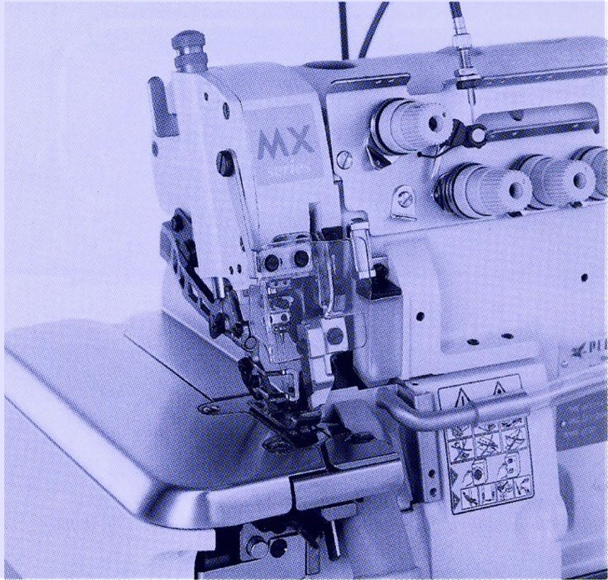

- 2-needle, 4-thread overlock for side seaming with manual backlatching
- BT0D manual backlatching device with retractable chaining off finger, actuated by cable
- economical mechanical solution
- in basic version is no compressed air needed
- needle distance 2 mm, overlock width 6 mm
- max. stitch length is 3,8 mm
- oil lubrication by oil pump
- max. speed is 7500 rpm

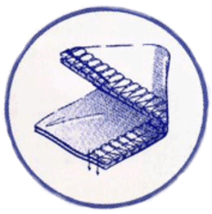

NEW LC – device is option
(including waste suction)

Subclass Specifications

