New Model of W1662 for hemming operations on T-Shirts,

Polo-Shirts, under wear etc., equipped with left knife FT0C

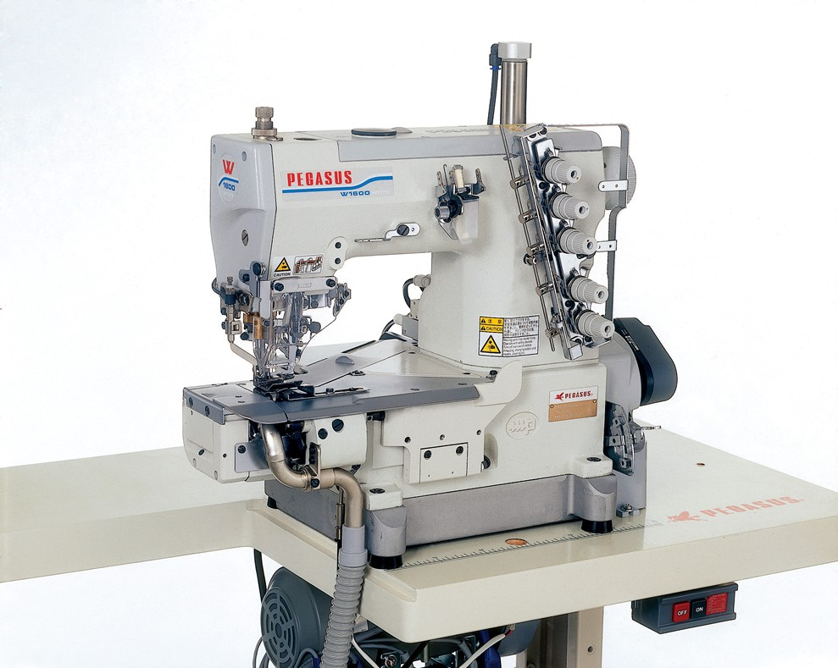
- 3-needle, 5-thread cylinder bed Interlock stitch machine for hemming operations on T-Shirts
- equipped with fabric edge trimmer at left side of needles, FT0C
- FT0C ensures that the fabric is always inside the seam (optional 1-2 mm outside the seam)
- hem width is very accurate all way round with +/- 1 mm
- tight seam and soft seam is adjustable
- also available with 3 needles in 6,4 mm; and 2- needles in 4,8 mm
- stitch length adjustment by push button
- max. speed is 5000 spm

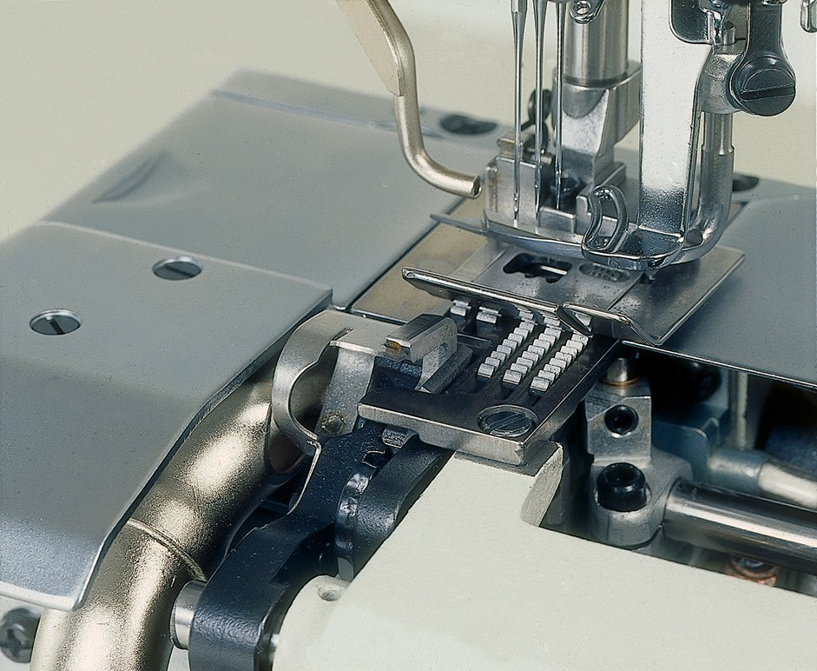
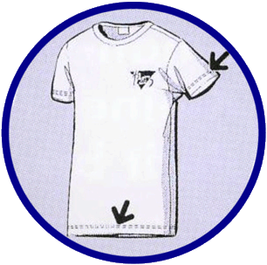
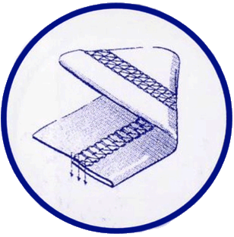
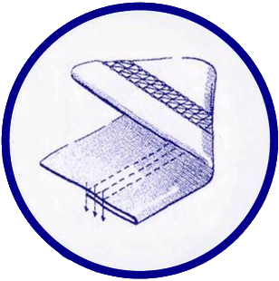

FT0C, fabric trimmer at left side of needles

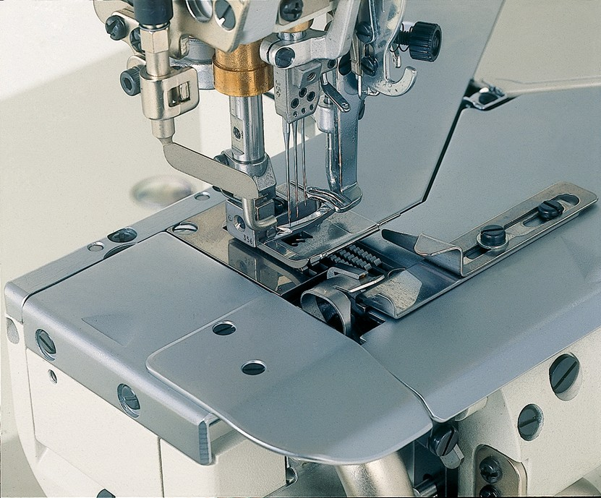
Subclass Specifications

