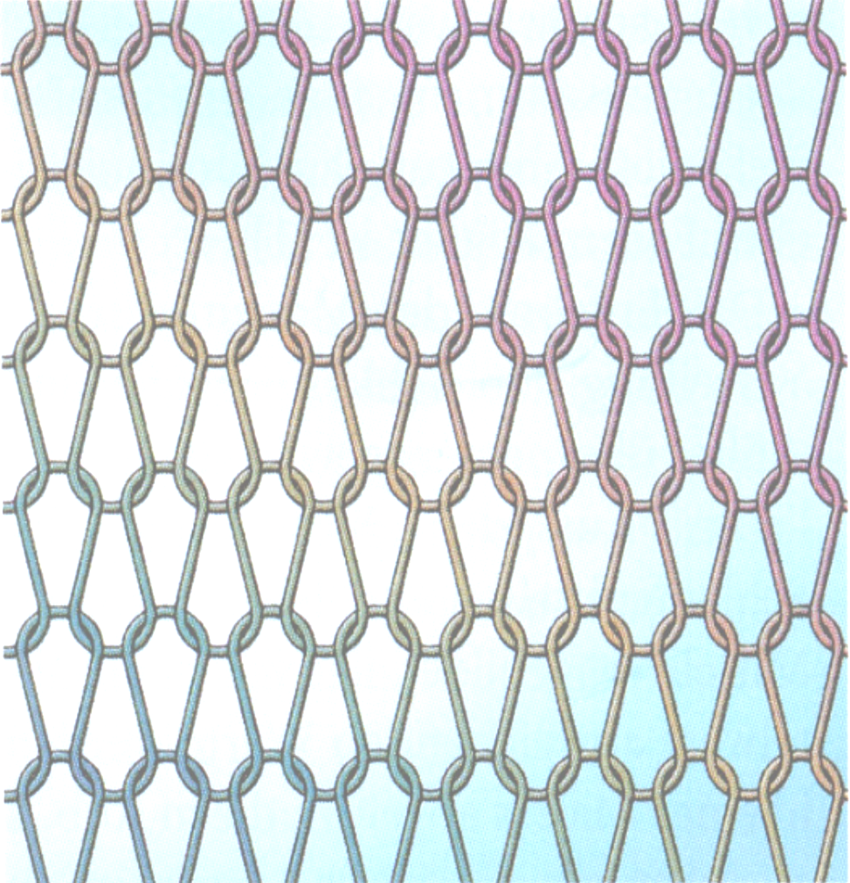

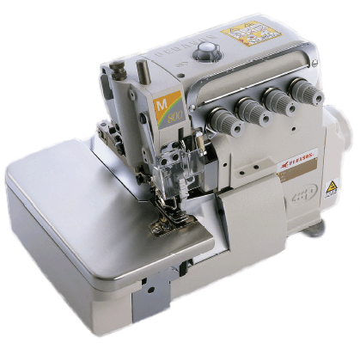
PPE - News, 2007
Pegasus Europa GmbH, Luxemburger Str. 5, D – 67657 Kaiserslautern
Tel.: 0631-303-28500, Fax.: 0631-303-28550, www.pegasus-europa.de
Introduction of M800 Series
M800

M700 with
open needle bar drive mechanism



M800: Upgraded New M series Overedger + Safety stitch machine
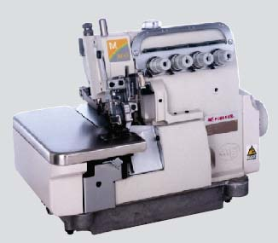


The new M800 development offers higher speed of up to 7000 rpm and ensures higher productivity. M800 - series offers many new features in comparison to M700. We introduce to you the outstanding new technical points:

- Fully enclosed needle bar casing, like MX and EX- series and the vacuum suction of the oil ensure
  - reduced noise from needle bar at high speeds
  - no excessive oil in the needle bar area
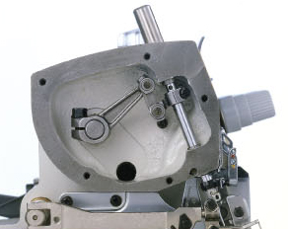

NEW

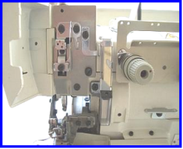
- An additional adjustment to the sewing condition is possible with
- the high position
- or down position
of the presser bar hinge mechanism

NEW
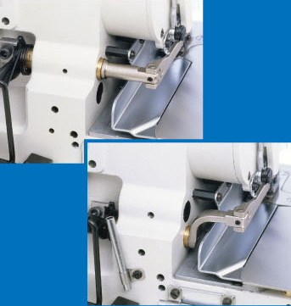
High axis is used for knitted fabric and Jeans machine. Low axis is used for woven fabric to reduce puckering.

- Improved ease of operation & maintenance
  - manually adjustable presser foot pressure
  - differential ratio adjustable from outside
  - movable needle guards
  - colour marked thread guides for easy and simple threading
  - tilt adjustment of feed dog bars from the outside

- Improved oil gaskets on oil pan and top cover, with “M” shaped O-ring
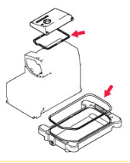
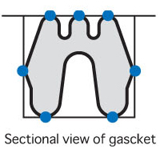

- Rustproof coated gauge parts to protect against fabric with chemical treatments and moisture

NEW
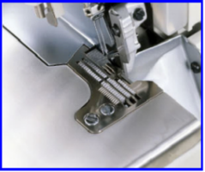

- 3 oil seals are used on the feed dog bars

NEW

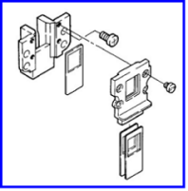

- Gauge parts from M700 are used for M800
Exception: NEW
The upper looper for 2-ndl (the models which have 2-ndl.overedger stitch, including -355) is newly designed.
The upper looper of M700 can not be used for M800 models which have 2-ndl. overedger stitch, including -355. All loopers from other subclass models are common with M700.

- 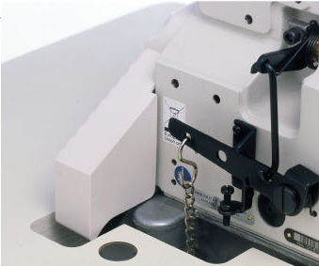New designed belt cover with closed rear side for improved safety NEW

- Eye guard with closed left side for higher operator safety
NEW
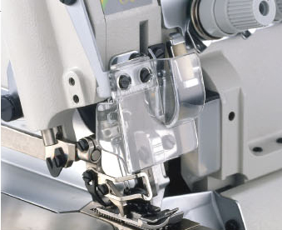

- Common with M700:
  - HR-device, for needle thread
  - and needle cooler

  - Movable needle guards

  - oil circulation check-up window on top cover and oil level window on front side of casting

    - Labour saving devices

  - Vertical chain cutter KS for the overlock machines, KS0C, KS0E

  - Horizontal chain cutter KH for the safety stitch machines, KH0A, KH0B, KH0C

  - Tape and chain cutter TK
  - a, solenoid driven
  - b, pneumatic driven

  - New LC with lint collector

Suitable table top for M800

For fully submerged installation the EX table top has to be modified slightly in the area of the belt cover.
For semi submerged installation the EX table top can be used with modification on the cut out of the V-belt. It must be 2,5 to 3 cm shorter at the rear side. All other dimensions of the table top are identical to EX.

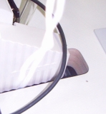
this area has to be cut out shorter by 2,5 to 3 cm.
This hole must be closed according to CE.

M800 - Common Specifications

Subclasses: M852: -01, -17, -16S2,
-13 and –23B, (in plan –90 )
-13/Y with chaining land
-180/BT0B, -181/BT0C
M832: -38, -70, -86, -355
-48, -48P2

Max. speed: 7.000 rpm * The maximum speed is different depending on the subclass and the sewing condition
Standard needle: B27
Presser foot: Tractor presser foot for –86, Jeans

Feed type: Differential bottom feed
Stitch length: 0.8 ～ 3,2 mm
Differential ratio: 1：0.7 ～ 1：2,8
Standard stitch length: max. 3,2 mm
Stitch length adjustment: Push button type
Diff. feed amount adjustment: Intermittent type (without micro adjust)

Devices : KH / KS, TK, LC

Available Subclasses:

1, M852 Overlock Machines
Plain seaming,
1-needle and 2-needles

M852-01-4
M852-17-4
M852-16S2-1,5
M852-13-2x4
M852-23B-2,5x4,5
M852-13-2x4/Y3061, with chaining land
M852-180-4/BT0B
M852-181-2x4/BT0C
M852-90-6 (in plan)

2, M832 Safety stitch machines

M832-38-3x4
M832-70-5x5
M832-86-5x6
M832-355-3x2x4
M832-48-3x4
M832-48P2-3x4

3, M822 Double chainstitch
machines

M822-02x250

The new parts checker for M800 is available for download in the section PE-News and on our WebPage in the section products.

You also can download the PE-News as PDF – file and as original Word document for your translation, to make it available in your native language for your sales and technical staff.

Major advantages of M800
in comparison to M700

- Fully enclosed needle bar drive mechanism with oil suction on needle bar bushing
  - reduced noise from needle bar at high speeds
  - no excessive oil in the needle bar area

- An additional adjustment to the sewing condition is possible with
  - the high position
  - or down position
of the presser bar hinge mechanism, allowing optimum adjustment for pucker free sewing on knits and woven wear.

- Rust proof coated gauge parts

- Same gauge parts as M700
- exception is new looper of stitch type 514

- Many improvements with respect to ease of operation

- and easy maintenance

Ullrich Rabe, PE

